**AYESHA ASHRAF**

**DEEP LEARNING –(TASK 1,2)**

**What is Git??**

It’s a version control system.

* first install the Git
* second write the command in git bash

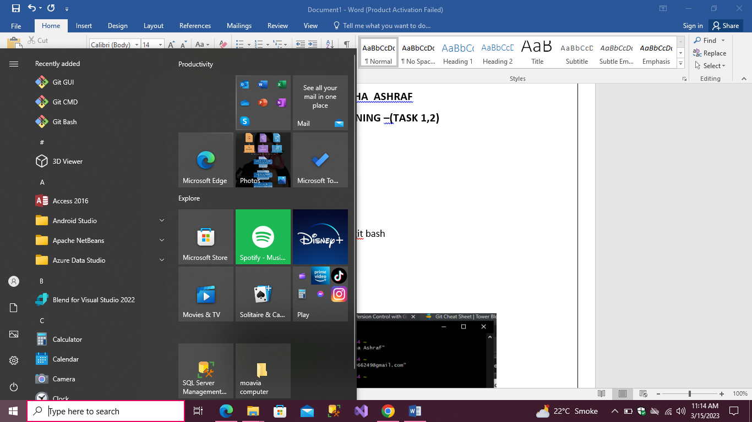

* To configuration with git.

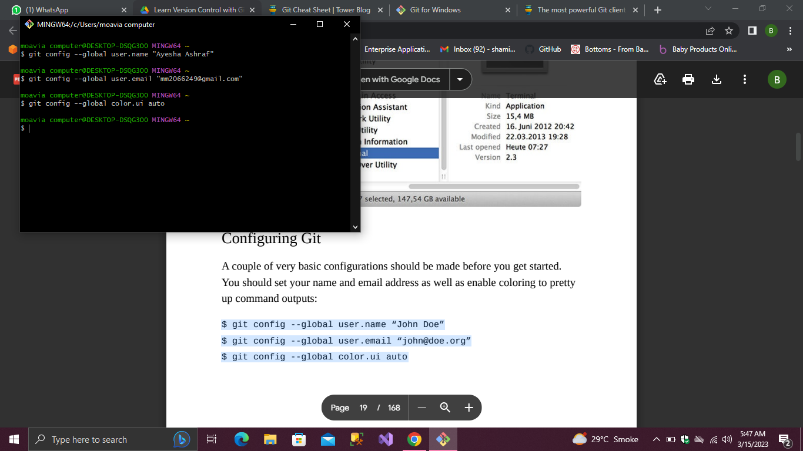

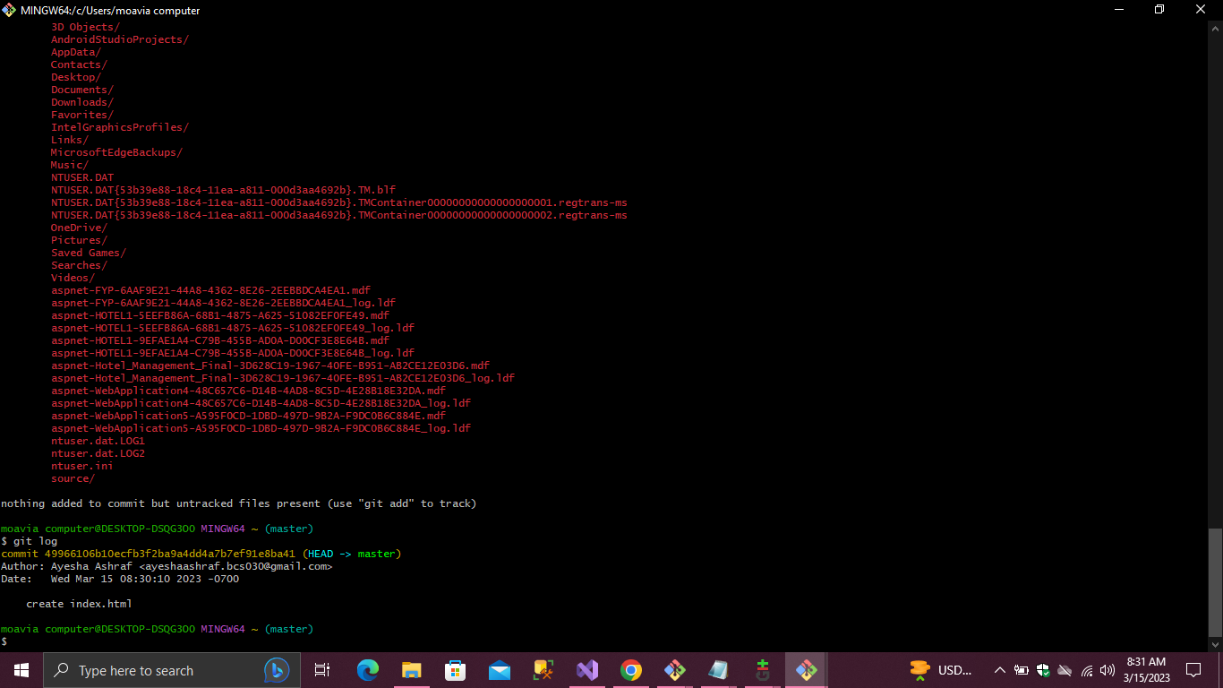

**Git init command**

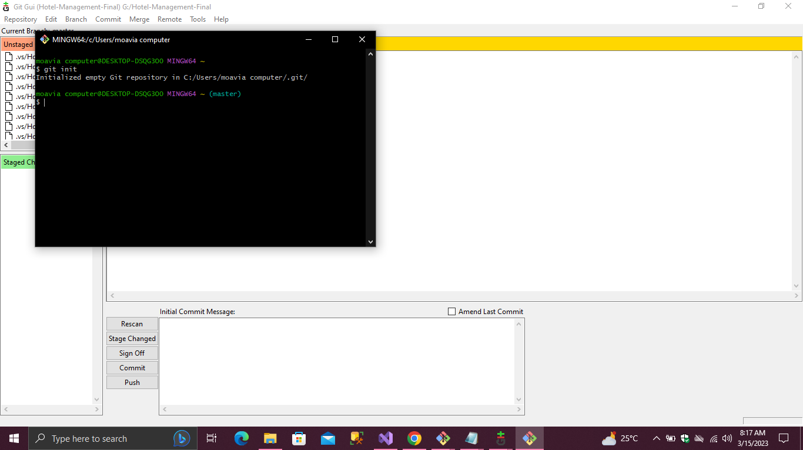

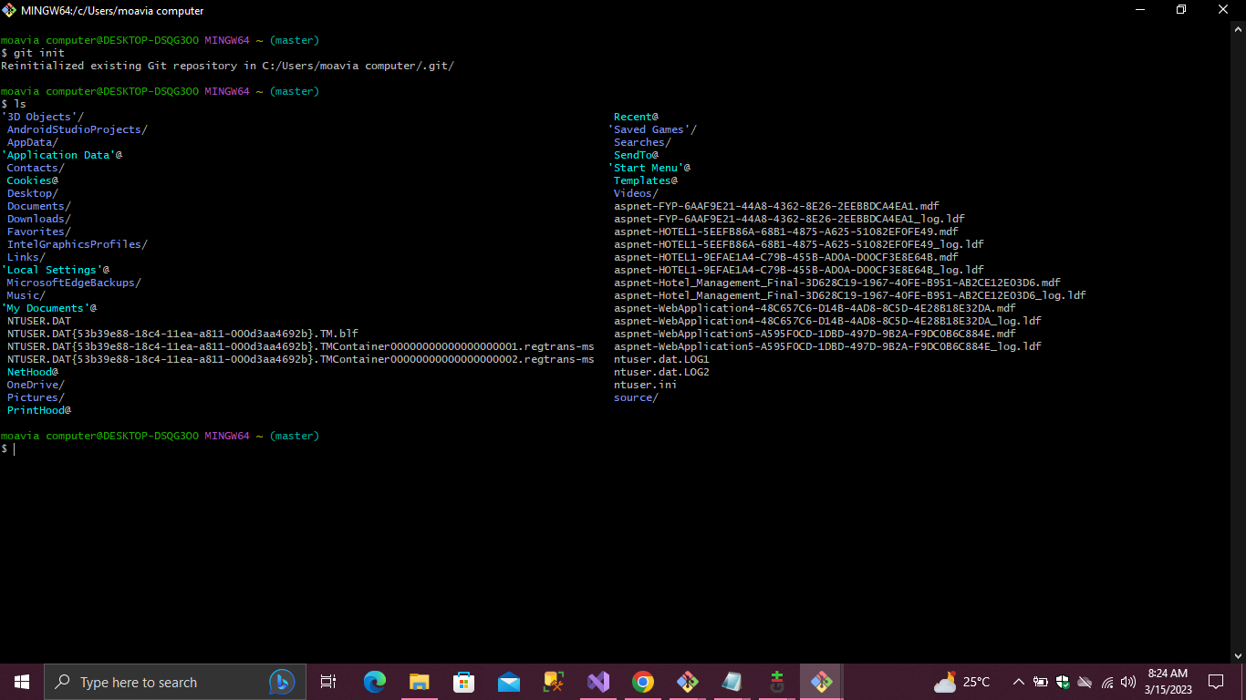

Ls-a .git command

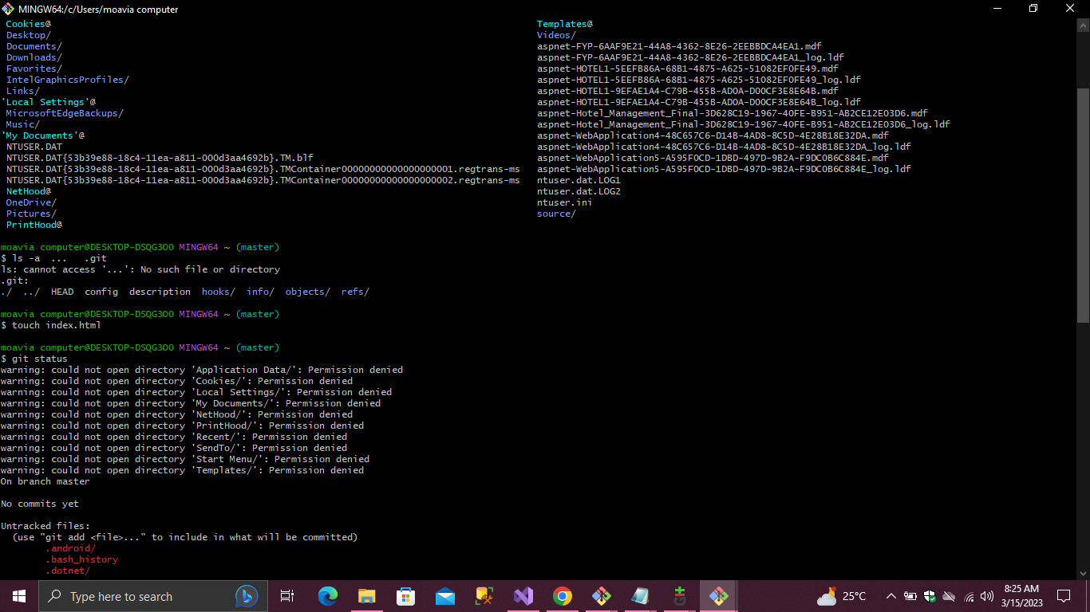

Git in visual code

Integrate git with visual code using git bash in terminal

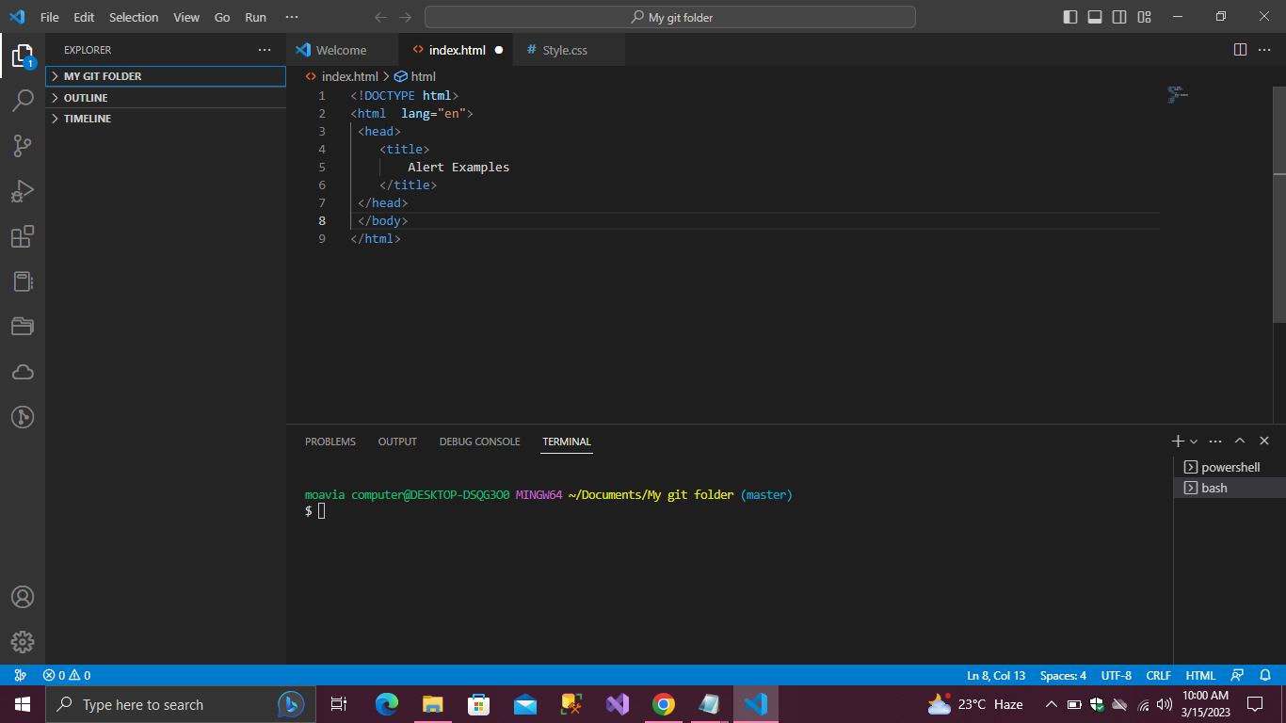

Using Git bash to make file in folder of visual studio.

File name is “index.html” created.

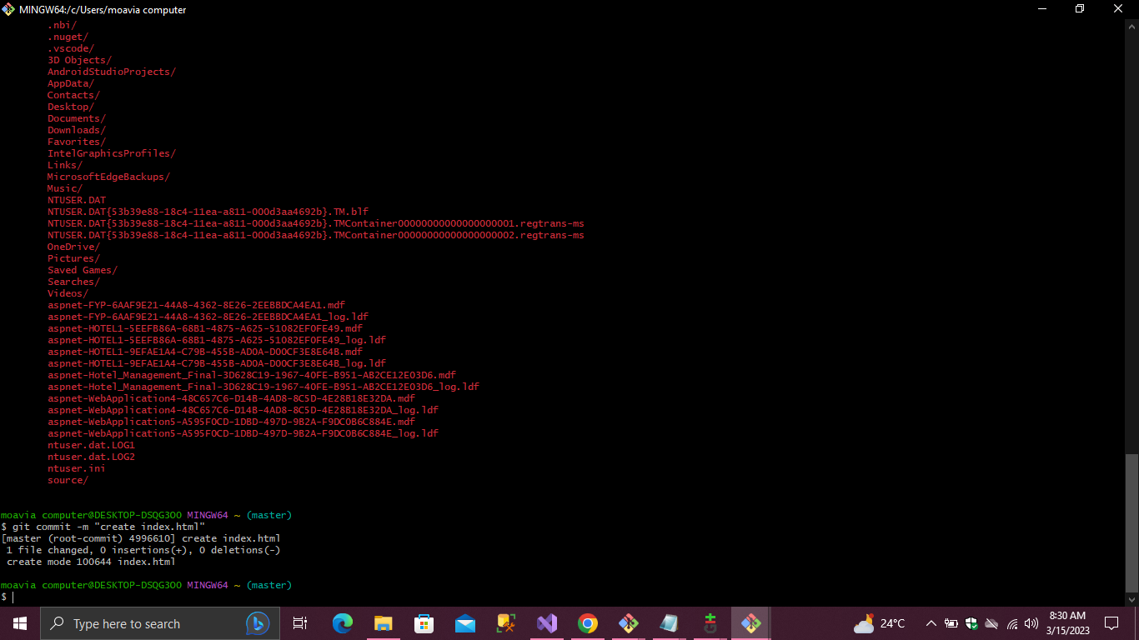

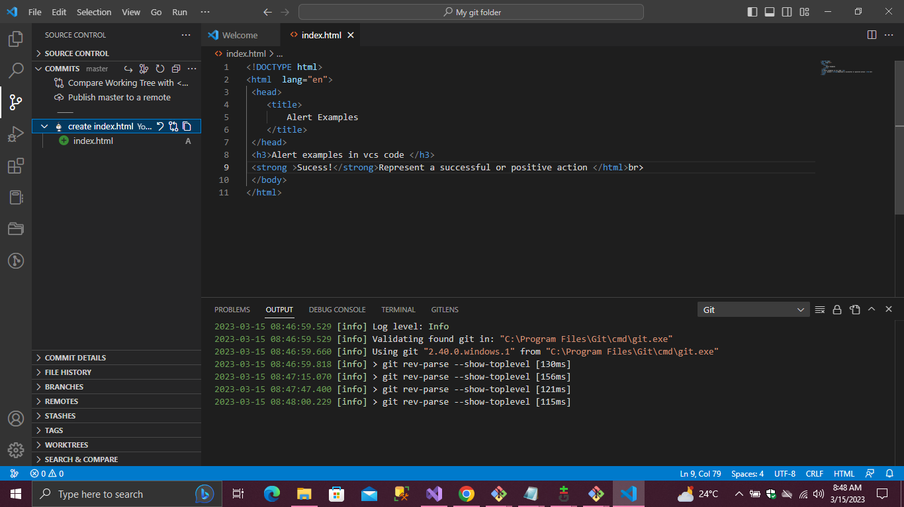

Master branch of project

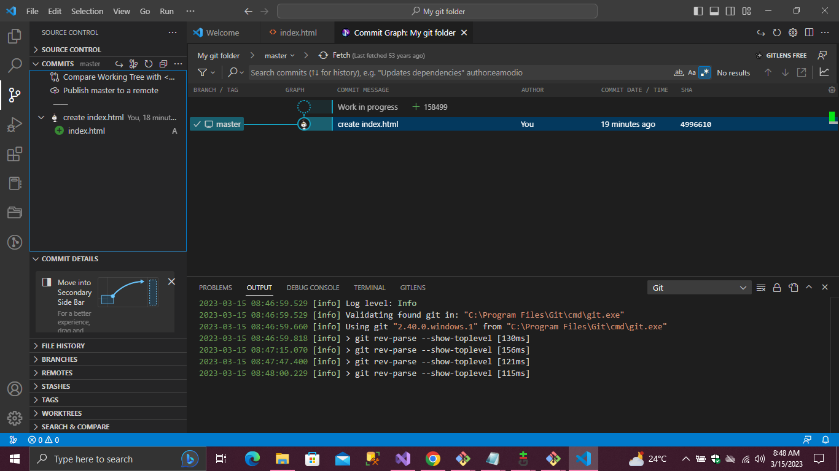

Make a new branch named as “New ”

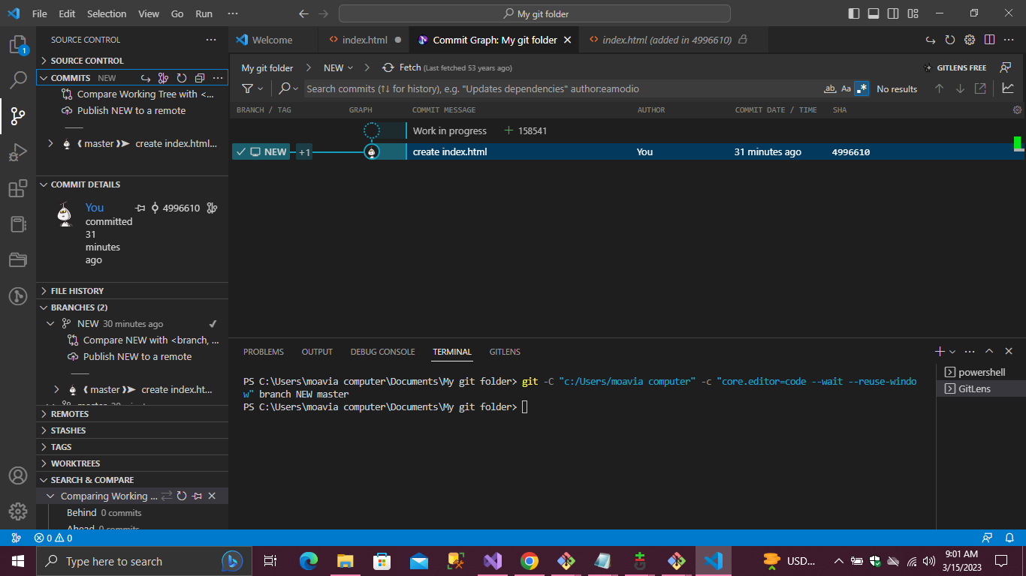

Also use Git in visual studio

Here are the projects which have different branches and the code push in github .

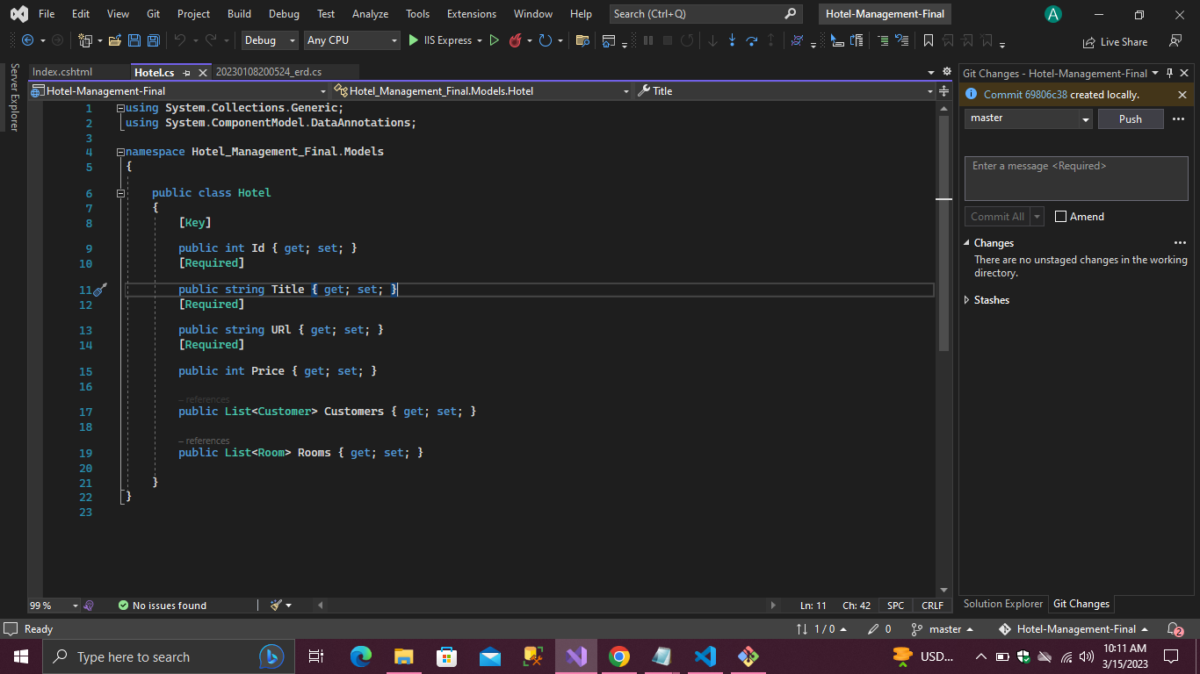

Remote Git Repository

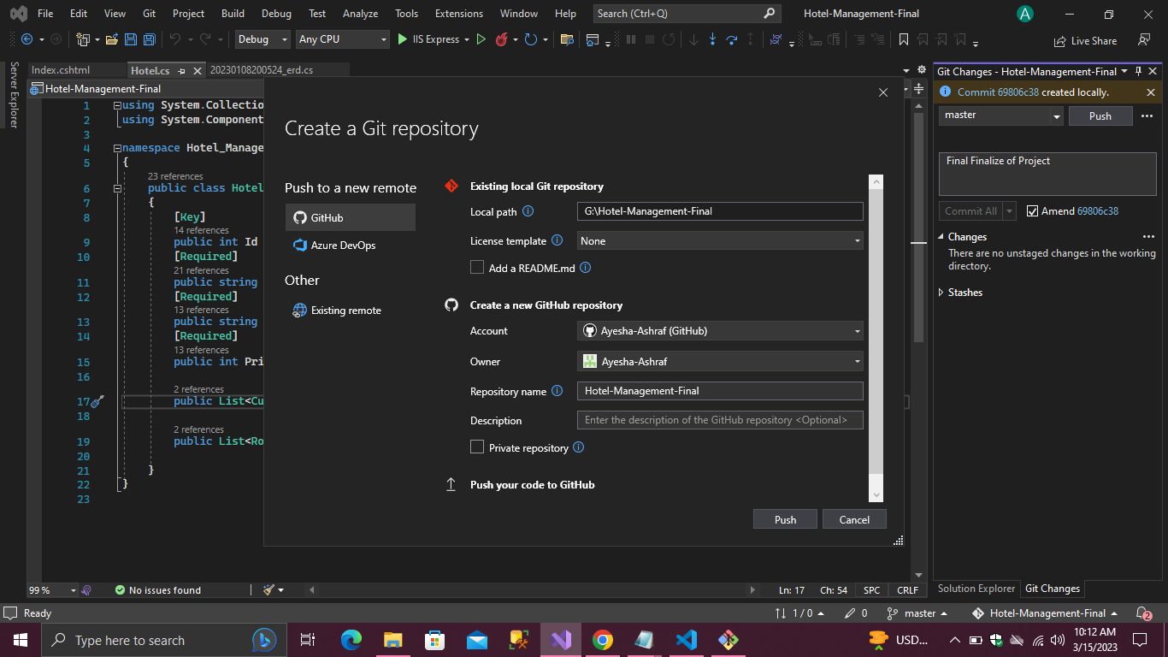

Commit changes and push to github

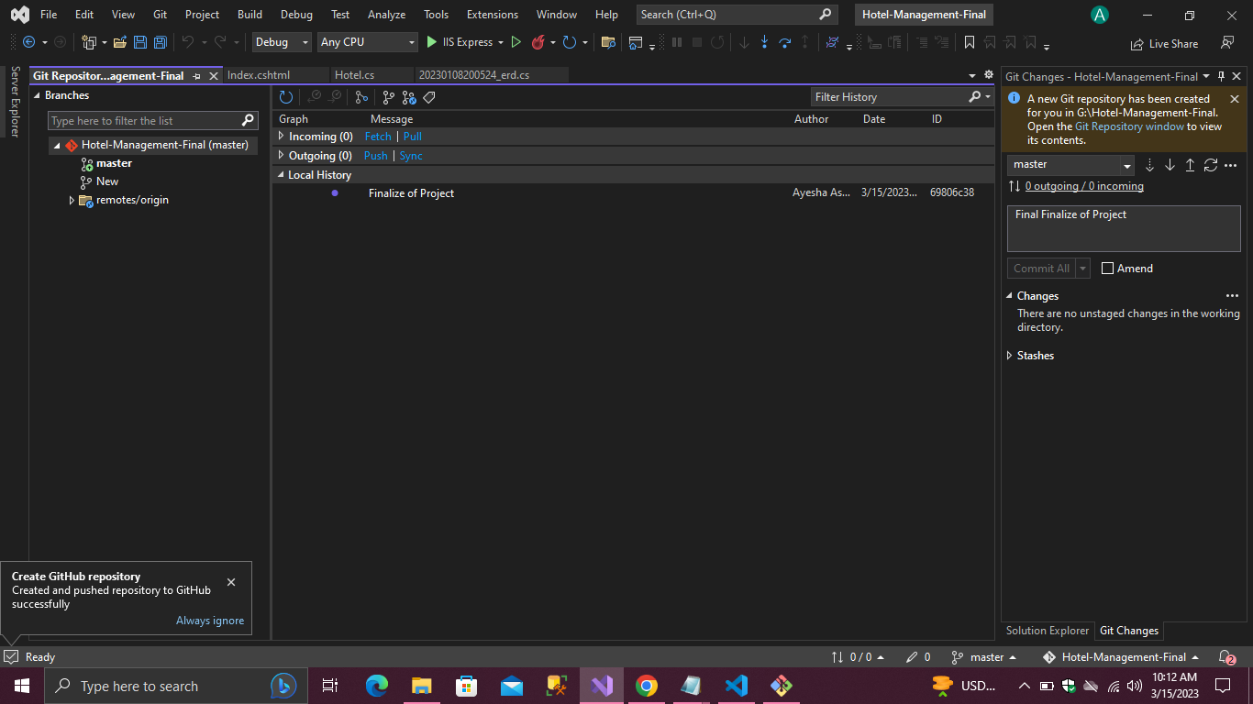

Read Me file in git Repository

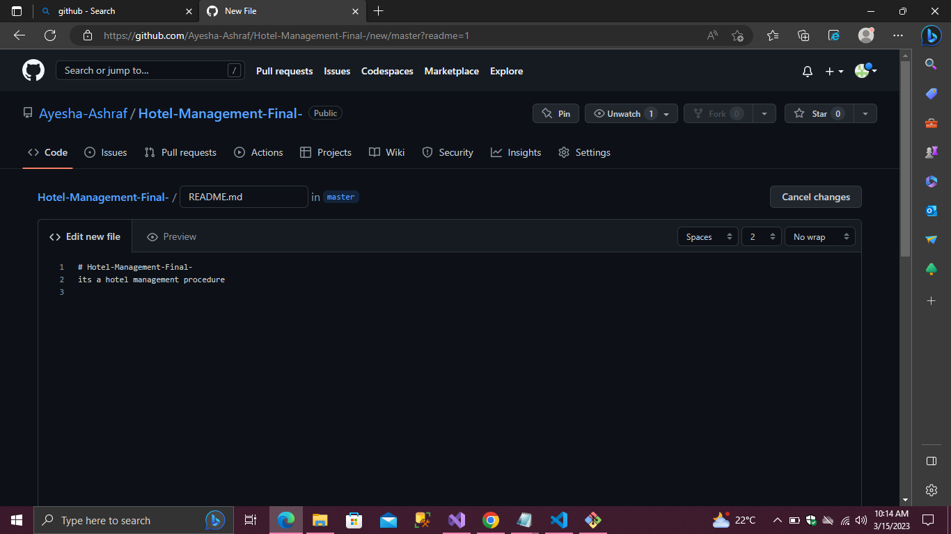

Branches in github

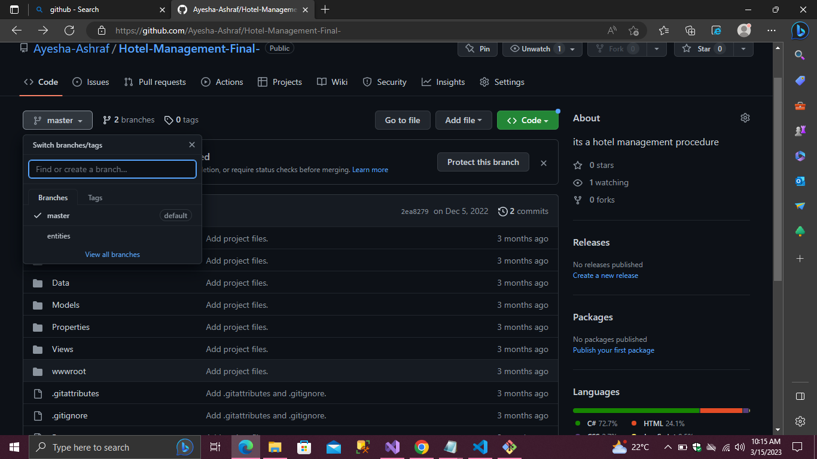

Github tasks screenshots.

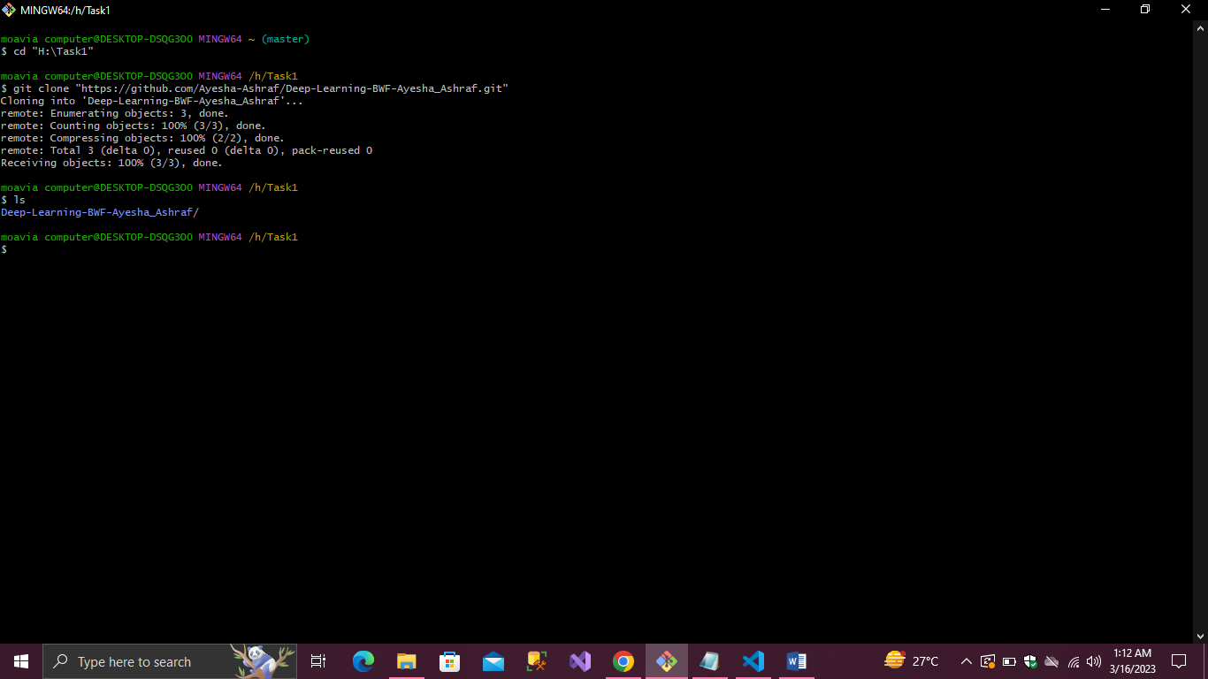

Git commit & git status

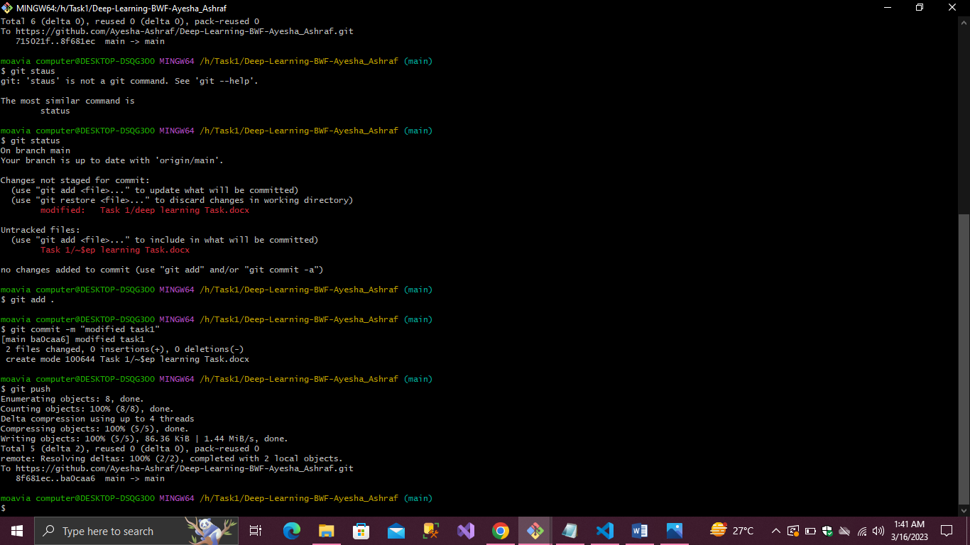

If git is modified than again chech status,commit if modified and push to github.